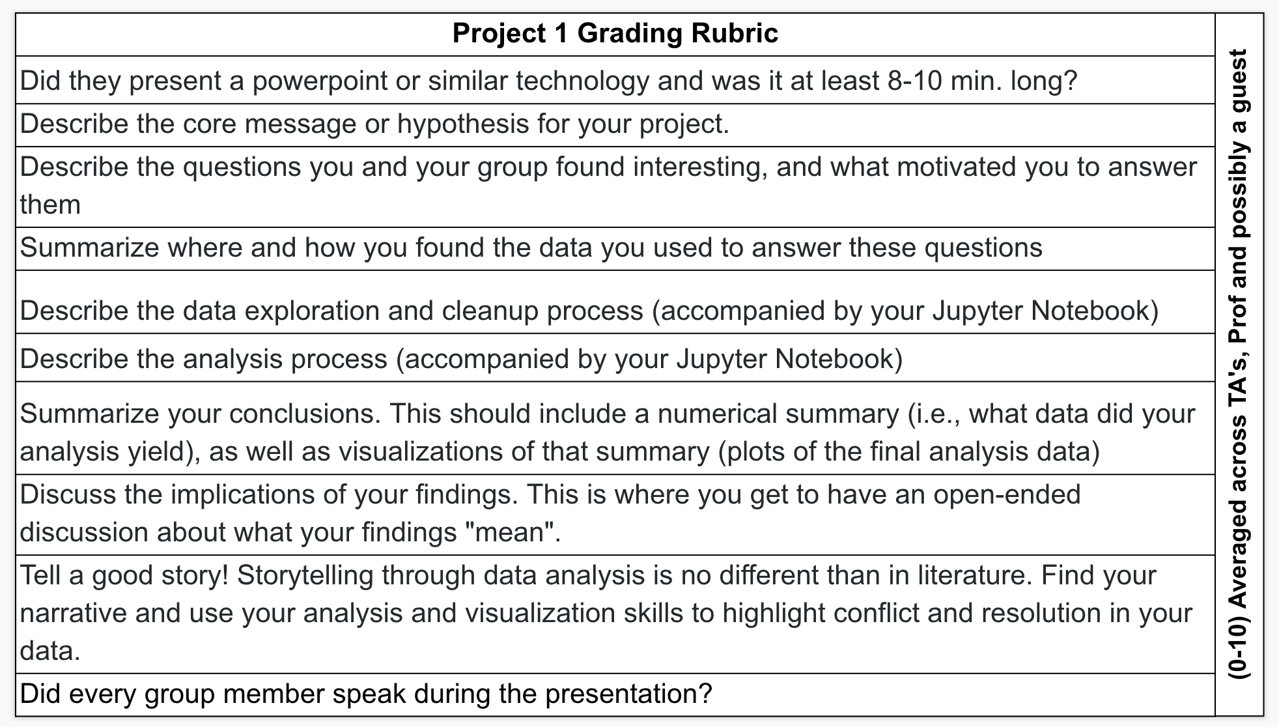

**Potential Slides**

Title Slide

Team Members

Project Background

Our Process

Hypothesis

Peek at the Initial Data

Jupyter Notebook Snapshot

Stats - T Tests

Chart 1

Chart 2

Chart 3

Chart 4

Our Findings

Other Considerations

Questions/Thank You!